Occupational Hazards and Fire Safety Training for Newly Enrolled Students

Faculty: Dentistry

Definitions

Personal Safety
In the literal sense, “safety” stands for the state of non-danger or peace of mind. The term “safety” corresponds to both the feeling of security and the actual lack of danger. Personal safety and hygiene at work regulations are aimed at preventing accidents in the workplace and providing safe and healthy work environment. The rules and regulations regarding personal safety at workplace are both established by appropriate laws and the extra-legal scientific achievements, and arise from common sense and personal experience.

Personal Hygiene
”Hygiene” stands for the set of conditions that exert positive influence of human health. Hygiene is a field of medicine concerned with the factors improving an individual’s and a society’s health, and with studying the influence of such external factors as light, water, etc. on that health. In the context of safety at work, work hygiene will stand for providing work conditions that adhere to the current standards on external (noise, vibrations, light intensity or order in the workplace) and internal (overall health condition of the employee, their psychophysical condition) factors.

Safety at Work
Safety at work comprises of a set of legal rules and regulations on work conditions, aimed at preserving life and health in work environment, and protecting the interests of the employees. The main aim of safety at work regulations is protecting an employee from dangers arising from performing assogned work by providing appropriate working conditions.

LEGAL PROVISIONS – OCCUPATIONAL SAFETY AT A HIGHER EDUCATION INSTITUTION

ORDINANCE OF THE MINISTER OF SCIENCE AND HIGHER EDUCATION
of July 5th 2007
on personal safety and hygiene in higher education institutions

(Dz. U. [Journal of Laws] of July 18th 2007)
Art. 1
A Rector is obligated to organize safety and hygiene at work trainings for persons obligated to complete such trainings pursuant to the ordinance of the Minister of Economy and Labor of July 27th 2004 on safety and hygiene at work (Dz. U. no. 180, item 1860 and of 2005 no. 116, item 972).

Art. 2
1. A Rector is also obligated to organize safety and hygiene at work trainings, minimum 4 hours long, for all students commencing their studies at his/her higher education institution.
2. The trainings should be held, as an integral part of the curriculum, as lectures, seminars, or classes. The student’s participation has to be documented with a credit.
3. The program of the training should cover a selection of legal issues, information about health and life hazards, precautionary measures and procedures in case of the aforementioned hazards, including giving first aid.
4. The detailed scope and program of the training for students and the maximum size of the training groups is set by the Rector, depending on the character of the basic organization unit of the institution.
5. The training on safety and hygiene at work should be held by persons possessing adequate knowledge and occupational experience in the field of the training.

Art. 3.
1. A Rector is obligated to provide employees with necessary means of personal safety, work clothes and shoes appropriate for the type of classes and the requirements of the study major.
2. A Rector is obligated to provide students with necessary means of personal safety, depending on the type of classes and the requirements of the study major or research.

Art. 4.
1. The Institution’s buildings, grounds and appliances, in accordance with their use and designation, should comply with rules and regulations specified in the ordinance of the Minister of Infrastructure of April 12th 2002 on technical specifications for buildings and their placement (Dz. U. no. 75, item 690, of 2003 no. 33, item 270 and of 2004 no. 109, item 1156) and rules and regulations of the Labor Code of June 26th 1974 (Dz. U. of 1998 no. 21, item 94, as amended, amendment 3) and accompanying implementing provisions, hereinafter referred to as “Occupational Safety Provisions.”
2. The facilities should be equipped with portable fire fighting equipment, depending on the explosion hazard, the level of danger to humans, fire load density, in accordance with fire safety rules and regulations in force. The equipment should be maintained in a ready-to-use condition.
3. The institution’s buildings where employees have their work stations and classes are held should include sanitary facilities with appropriate equipment and maintained in clean and usable condition.
4. Emergency routes and other routes and passages for pedestrians on the institution’s grounds should be properly maintained, so that they do not pose a threat to the users.
5. The institution’s facilities should adhere to the rules and regulations regarding lighting, air circulation, heating and floor space, specified in the ordinance of the Minister of Labor and Social Policy of September 26th 1997 on general terms and conditions of safety and hygiene at work (Dz. U. of 2003 no. 169, item 1650 and of 2007 no. 49, item 330) and including the requirements and function of particular rooms.
6. The amenities of the Institution’s facilities, especially: furniture, equipment, devices and installations cannot pose a threat for persons using these facilities.
7. Particular care for precautionary measures should be exercised in the Institution’s buildings used for pilot studies, experiments in chemistry, physics, etc. that can constitute health or life hazards. Instructions on preventing human life and health hazards should be posted in areas where research and experiments are carried out.

Art. 5.
A Rector is obligated to maintain the Institution’s facilities, appliances and sports grounds in conditions allowing safe and hygienic use and to provide supervision of qualified and authorized staff during physical education classes and any sports competitions held by the institution, pursuant to the provisions of the June 18th 1996 Act on Physical Culture (Dz. U. of 2001 no. 81, item 889, as amended, amendment 4).

Art. 6.
1. A Rector may suspend classes at the institution, if the temperature in the study areas is below 18°C.
2. A Rector may also suspend classes at the institution or temporarily close the institution or its unit, if a given area is affected by a natural disaster, epidemic or other threats to life or safety of the employees or students.
3. Upon establishing that either the employees or students perform their activities in a way that poses a threat to life or health, the rector is obligated to stop the performance of said activities and propose a safe way of executing them.

Art. 7.
1. Upon establishing that the area where the classes are to be held or the appliances in that area are in a condition that may pose a threat to the safety of students, the rector is obligated to prevent the commencement of classes, stop the classes or propose actions and protocols that will allow the classes to be held in secure conditions.
2. A rector is obligated to ensure that the instructors in workshops, specialist research laboratories, general laboratories and physical education instructors have received first aid training.
3. At least one portable first aid kit, with first aid essentials, should be available in each room at the institution available during lecture or research hours. The contents of the first aid kit should not exceed its expiry date. An instruction on providing first aid should be attached. The used materials should be replaced immediately.

Art. 8.
1. Separate occupational hazards protocols set for particular branches or types of work, as well as the rules and regulations set herein, are enforced in general laboratories, workshops, specialist research laboratories.
2. The machines and other appliances in general laboratories, workshops, specialist research laboratories should:
1) be equipped with security measures preventing the employees and students from injuries, exposure to dangerous chemicals, electrocution, excessive noise, noisome concussions, the effect of vibrations and radiation, and noisome and dangerous effect of other work-environment factors;
2) account for the ergonomic rules;
3) be maintained in a state ensuring operational capacity and safety during work.
3. Equipping general laboratories, workshops, specialist research laboratories with machines and other appliances that do not meet the requirements set in rules and regulations on assessment of compliance is forbidden.
4. Machines and other appliances that are temporarily out of order, damaged or in repair should be clearly tagged and secured, so that they cannot be switched on.

Art. 9.
1. A Rector is obligated to provide the employees and students using the general laboratories, workshops, specialist research laboratories with instructions including occupational hazards rules and regulations establishing, in particular:
1) the safety rules and regulations for operating machines and other appliances;
2) which types of work and technological processes in particular carry life and health risks and how they ought to be supervised;
3) methods of handling dangerous and hazardous materials;
4) the system of signs and signals, as well as light and sound signals, currently in force;
5) instructions for using personal safety and emergency means and measures;
6) instructions for handling situations posing life and health risks, which include providing first aid.
2. A Rector is obligated to appoint persons responsible for checking whether the technical state of machines and appliances and the electrical wiring, the general state of the general laboratory, workshop or specialist research laboratory does not pose life or health risks, prior to commencing classes and making them available to students and employees.
3. A Rector is obligated to appoint a person responsible for the safety of students during classes.

Art. 10.
1. A Rector is obligated to ensure that the classes at the institution are supervised by an employee or an instructor who has appropriate certification in holding classes according to occupational hazards rules and regulations.
2. A Rector is obligated to ensure that the students are trained in occupational safety procedures prior to commencing classes which require the use of machines and other appliances, or classes in general laboratories, workshops or specialist research laboratories, and appoint persons responsible for conducting these trainings.

Art. 11.
1. A Rector is obligated to establish the principles for handling chemical substances and preparations, noisome biological factors, carcinogenic or mutagenic substances, preparations and factors and radioactive materials, having in mind the rules and regulations regarding these substances, preparations, factors and materials.
2. A Rector is obligated to ensure that dangerous substances and preparations are kept in closed, properly prepared and clearly tagged rooms and areas, in secure containers that prevent noisome, dangerous effects of these substances, fire or explosion.
3. A Rector is obligated to ensure records are kept on the dangerous waste produced at the institution, their collection and disposal.
4. A Rector is obligated to ensure that students exposed to factors hazardous to health have to undergo physical examination pursuant to the terms and conditions set in the ordinance of the Minister of Health and Social Security of September 15th 1997 on physical examination for candidates to secondary schools or higher education institutions, pupils, students and doctoral students, who are exposed to factors that are noisome, oppressive or dangerous to health during practical occupational training or studies, and on documentation of these tests (Dz. U. no. 120, item 767 and of 1998 no. 58, item 374).

Art. 12.
1. The state of the wiring and equipment and appliances in student dorms cannot pose a threat to their inhabitants and the personnel working there.
2. The living areas in student dorms should consist of at least 5m² of living space per person.
3. The lighting, air circulation, electric wiring and gas train, and all technical appliances in student dorms should comply with technical specifications established in rules and regulations on technical specifications for buildings or Polish Standards.

Art. 13.
1. The institution’s facilities should be maintained in proper sanitary condition.
2. Facilities containing showers, bathrooms, toilets, washrooms should be heated and equipped with air circulation in accordance with the rules and regulations on the technical condition of buildings and Polish Standards.

Art. 14. Student dorms should have designated areas for learning and a community room, as per requirements.

Art. 15.
1. A Rector maintains a register of students’ accidents that happened during classes at the institution.
2. When establishing the circumstance and causes behind students’ accidents, appropriate rules and regulations apply. Detailed procedures are set by the Rector.
3. Based on the register referred to in 15(1), a rector is obligated to perform an annual analysis of the circumstance and causes behind accidents at the institution.
4. Based on the analysis referred to in 15(3), the rector is obligated to establish, after consultations with the chancellor and relevant safety and hygiene authorities of the institution, the main courses of action in regards to safety and hygiene at the institution.

Art. 16. Rectors of higher education institutions that do not meet the requirements regarding safety and hygiene set forth in this ordinance shall ensure that the requirements are met within one year of introducing this ordinance.

Fire Safety

Fire hazard is a set of factors that may cause the starting and spreading of fire and thus affecting personal safety.

Explosion risk:
Explosion risk is the potential of flammable gasses, vapors of flammable substances, and dust and fibers to create mixtures with air that upon contact with ignition factors explode, i.e. undergo rapid combustion paired with sudden pressure.

Fire triangle:
Source of oxygen (air)
Three factors are required for a fire to occur:
- Flammable material
- Oxygen
- Source of ignition (thermal stimulus, heat source)

Causes of fire:
Man-made fires, resulting from:
Source of ignition
Flammable material
- Carelessness
- Negligence
- Being unfamiliar and/or failing to adhere to fire safety regulations

Arson

Other fires:
Caused by thermal effect of sunrays on flammable materials through glass, atmospheric breakdown, etc.

If a facility does not have any equipment removing smoke or preventing high smoke density, the toxic output of combustion will spread freely in the building. Usually, fire should not spread beyond the affected room, however, if the fire starts in e.g. elevator, it can spread to other rooms and floors.

Fires in buildings constitute serious threat to life and health. Fire also poses a serious threat to valuable equipment in the building.

The most common causes of fire are:
- Leaving smoldering cigarettes and matches near flammable materials.
- Using provisional electrical wiring.
- Placing electrical appliances that are prone to overheating (cookers, heaters, kettles) next to flammable materials (furniture, drapes, carpeting, etc.)
- Overloading the electrical wiring.
- Not switching off recipients of electricity not adapted to continuous work.
- Inappropriate handling and failing to maintain appropriate safety measures when handling easily flammable materials.
- Insufficient security measures preventing third parties from entering the building.
- Using flammable materials as cover for light-sources.
- Inappropriate or excessive maintenance of appliances and electrical wiring.
- Failing to adhere to safety protocols when performing tasks causing fire hazard (welding, unfreezing, heating with a blowtorch during construction works, etc.)
- Careless handling of flammable substances in laboratory areas.

Fire Classes
Classification of fires based on the type of flammable materials:
A fire involving organic solids, where other phenomena are accompanied by incandescence; e.g. wood, paper, coal, plastics, materials, straw
B fire involving flammable substances and solids liquidating due to the heat from the fire; e.g. gasoline, alcohols, acetone, oils, varnish, fats, paraffin, stearin, pitch, naphthalene, tar
C fire involving gas; e.g. methane, acetylene, propane, hydrogen, city gas
D fire involving metals; e.g. magnesium, sodium, uranium, aluminium

Each class of fire is designated a fire extinguisher, marked with letters A, B, C, D. The types of fire extinguishers are based on the type of fire they are able to extinguish.
Fire extinguishers are also classed based on the method of storing the expellant:
type X – stored pressure extinguishers, the expellant and the extinguishing agent are stored in the came container;
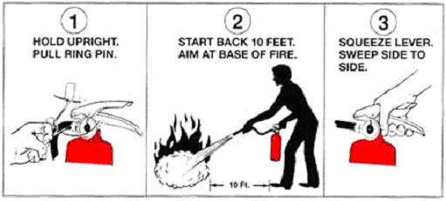

type Z – cartridge-operated extinguishers, the expellant is stored in a separate container, called the cartridge;
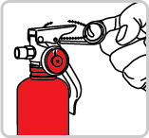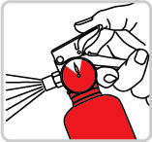
1. Pull the pin 2. Squeeze lever, release, wait 3s.

The basic principles of extinguishing fire with a fire extinguisher:
- Approach the fire downwind (not upwind)
- Start the fire extinguisher (in accordance with the manual) and direct the extinguishing agent of the source of fire
  - when a flat surface is on fire, begin extinguishing with from the nearest edge, direct the stream almost parallel to the burning surface
  - falling burning drops or liquid should be extinguished by directing the extinguishing stream upwards
  - burning vertical surfaces should be extinguished starting from the lowest point
- If there is a need to extinguish the fire with more than one extinguisher, use all of them simultaneously.
- After the fire has been extinguished, make sure re-ignition won’t occur.
- Having used a fire extinguisher, hand it in to the workshop.

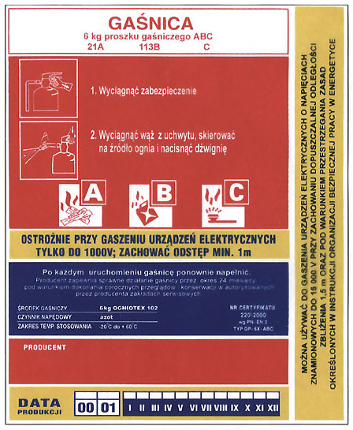
Each fire extinguisher has a description with the following information:
• information on the extinguishing agent ,
• the capacity of the extinguisher,
• tagging for the type of fires the fire extinguisher can
extinguish,
• picture and written instructions for use,
• information about the capacity to extinguish fire
on live electrical devices

The extinguishing agent can be:
powder – P
foam – W
carbon dioxide - S

In the event of fire

If you notice a fire or signs of fire, remain calm, do not cause panic, immediately switch on the manual fire alarm (ROP – if available on the premises) and immediately alarm (inform):
- persons in the endangered part of the building – begin evacuation if necessary
- the head of the unit managing the building – or other official who informs the rector or prorector or the chancellor,
- porter,
- security,
- the fire department (if necessary).
If the fire alarm system detects fire, the person appointed by the manager of the building locates the source of alarm in order to confirm the fire hazard. After fire hazard is confirmed, the manager of the building or another official is responsible for alarming the fire department by doing the following:
- dial 998 or 112, an give the dispatcher information on:
      - the location of the fire (name of the facility and address),
      - what caught fire,
      - whether there are any people in danger (give an estimate how many),
      - how advanced is the fire,
      - whether there are any dangerous materials in the vicinity of the fire (explosives, toxic or flammable materials),
      - how to reach the building,
      - the name and surname of the caller, and the telephone number from which the call is made;
- having given all the information, wait for confirmation from the dispatcher of emergency services (do not leave the vicinity of the telephone, in case the dispatcher checks the credibility of the call);
- the employees who do not participate in the alarm call and are in no direct danger immediately begin attempts to extinguish the fire, using the nearest fire extinguishing equipment, bring fire extinguishing equipment to the affected area and provide aid to the endangered people, aid evacuation and evacuate the property.
If necessary, also inform:
- Emergency Medical Services tel. no 112, 999,
- Police tel. no. 997,
- Emergency Energy Services tel. no. 991,
- Emergency Gas Services tel. no. 992,
- Emergency Water-Sanitation Services tel. no. 994,
- other relevant services, if necessary.

How to proceed in the event of evacuation
The duties of the head of the unit managing the building
The head of the unit managing the building is directly responsible for the safety of persons and property during evacuation from the endangered building and is obligated to, in particular:
- establish the procedure in the event of fire or other local danger and evacuation,
- decide on the extent of evacuation, after consulting with the rector, chancellor, or in case of their absence their deputies,
- alarm or oversee the alarming of specialist emergency services,
- ensure that only people participating in the rescue operation can enter the building,
- designate assembly points for the evacuees with information boards,
- ensure that people inside the building are safe and can be evacuated,
- ensure that the escape routes and emergency exits are clear,
- appoint teams of employees (individuals) to conduct evacuation of people and property,
- check if the building is clear of people after the evacuation,
- inform the institution’s authorities managing the rescue operation that the evacuation has been completed,
- during the rescue operation, cooperate with specialist emergency services (Fire Department, Police, Emergency Medical Services, Emergency Energy and Gas Services),
- initiate trainings in practical evacuation of people and property from a building.
The duties of the employees, students and other people using the institution’s buildings during evacuation
Employees, students and other people using the institution’s facilities who are in the building
are obligated to have detailed and current information on evacuation and alarming, and the rules and regulations on evacuating from the building.
During evacuation, the employees and students are obligated to, in particular:
- strictly adhere to the guidelines of their supervisors and persons supervising the evacuation,
- stop all activities and leave the endangered area – find the nearest evacuation route,
- remain calm and not give into panic,
- persons assigned to the evacuation should commence assigned tasks,
- stop computer work and secure the access to electronic data from unauthorized people,
- turn off and secure all electric and gas appliances,
- prepare (secure) important documents and property for evacuation,
- close all windows,
- take personal belongings and documents,
- leave the room, close the door and leave the key in the outside lock,
- after leaving the endangered building, go to an assembly point.
The evacuees remain at the assembly point until there is a signal or a communiqué canceling the evacuation and they can return to their posts or classes, if they are not finished.
While on the evacuation route, it is forbidden to:
- stop,
- move ”upstream,”
- move in a direction other than specified by the evacuation signs.
If the evacuation route is filled with smoke, move along the right side in a hunched position.
The markings of routes, directions and emergency exits are consistent with the prevailing norm PN-92/N-01256/02 “Evacuation.”

No. | Evacuation sign | Meaning (name) of the evacuation sign | Shape and color | Meaning
1 |  | Direction of the evacuation route | Square or rectangular shape  Green background  White fluorescent symbol | Indicates the direction towards an emergency exit. Short arrows – to be used with other signs. Long arrow – to be used individually.
2 | 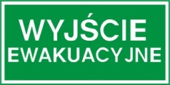 | Emergency exit | Rectangular shape  Green background  White fluorescent symbol | Marks exits used when an emergency occurs.
3 |  | Emergency door | Square shape  Green background  White fluorescent symbol | Sign used over French door that act as emergency exits (over the left or right side).
4 |  | In order to open: move sideways | Square or rectangular shape  Green background  White fluorescent symbol | Sign used with sign no. 3 over doors opening sideways that act as emergency exits, if allowed. The arrow should point to the direction the door should be opened.
5 | 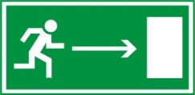 | Towards emergency exit | Rectangular shape  Green background  White fluorescent symbol | Points to the direction of the evacuation route; can point left or right.
6 | 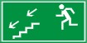 | Towards emergency exit down a staircase | Rectangular shape  Green background  White fluorescent symbol | Points to the direction of the evacuation route down a staircase; can point left or right.
7 |  | Towards emergency exit up a staircase | Rectangular shape  Green background  White fluorescent symbol | Points to the direction of the evacuation route up a staircase; can point left or right.
8 |  | Push to open | Square or rectangular shape  Green background  White fluorescent symbol | Sign placed over the door to indicate how to open
9 |  | Pull to open | Square or rectangular shape  Green background  White fluorescent symbol | Sign placed over the door to indicate how to open
10 |  | Break to gain access | Square or rectangular shape  Green background  White fluorescent symbol | Can be used: a) when glass has to be broken to gain access to a key or opening system, b) when glass has to be broken to create an exit.

Factors in the Work Environment:

Chemical, Physical, and Biological Hazards

Chemical

Division:
based on the possible effects and types of reactions:
- toxic,
- aggravating,
- sensitising,
- carcinogenic,
- mutagenic,
- affecting reproductive functions;
based on absorption:
- via respiratory tract,
- cutaneously,
- via mucous membrane,
- via gastro-intestinal tract;
based on the level of noxiousness:
- poisons,
- noisome factors,
- factors practically harmless to health.

Characteristic of chemical substance reactions
The following types of industrial poisoning with chemical substances can occur:
- acute – clear symptoms requiring immediate intervention,
- subacute – symptoms developing between a few hours and a few days from contact with the toxic substance,
- chronic – resulting from introducing small amounts of a noisome substance during a long period of time.
Effects of chemical reactions of toxic substances can be divided into:
- acrid;
- aggravating: -skin and mucous membranes, -eyes, -respiratory tract;
- sensitising: - with skin symptoms, -respiratory tract disorders;
- causing anoxemia: - simple asphyxiant gasses, chemical asphyxiant gasses;
- narcotic;
- teratogenic;
- embryo-toxic;
- geno-toxic;
- mutagenic;
- carcinogenic.

Cautionary pictograms:

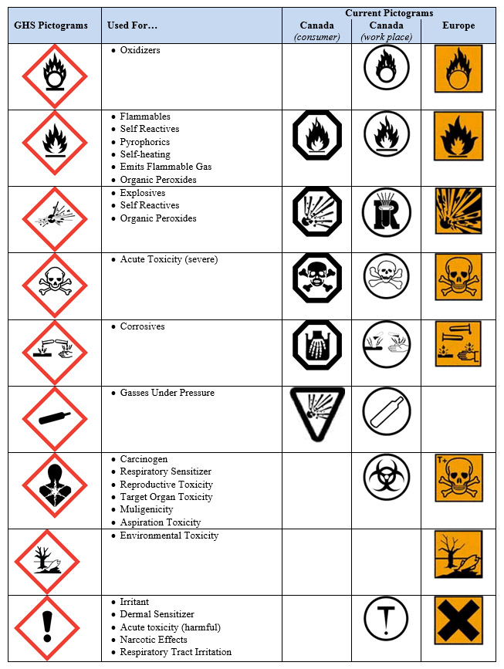
Prior to commencing work with a new chemical reagent, each student is obligated to familiarize him- or herself with safety data sheet for the reagent, which should have been supplied together with the reagent.

REMEMBER!!!!!

Each occupational exposure can be dangerous and requires an assessment of the possible degree of contamination. Timely counteraction can prevent contamination.

• Before each experiment, consider which chemical reactions and accompanying circumstances can be potentially hazardous and which preventive measures should be taken. In case of doubt, consult an assistant lecturer.

• To avoid making mistakes, check the label on the jar or bottle containing the chemical twice.

• The vessels for measuring or preparing solutions should be labeled with the name and concentration of the compound.

• Experiments during which toxic, acrid, and fetid gasses are produced should be performed beneath an extractor fan.

• Experiments requiring the use of greater amounts of poisonous, acrid, and in particular easily flammable substances should be performed under the supervision of an assistant lecturer. Persons working nearby should be warned.

• Do not taste liquid or solid chemicals. After working with poisonous substances carefully wash your hands.

• Pipettes for pipetting have special sucking mechanisms.

• Do not lean over containers with fluids being heated, do not put your head under a fume hood.

• When heating a sample, do not direct the outlet towards you, or your neighbor at the lab table.

• After spilling or scattering poisonous, acrid or easily flammable substances, immediately inform the instructor who will give you detailed information on what to do next.

• Always cover your hands with a towel when placing corks or rubber hose on glass pipes and rods. The external surfaces of the glass should be dampened with water or, even better, with glycerine in order to decrease friction between the glass and rubber.

• When removing air from a glass container (desiccator, laboratory flask) for the first time, wrap the container in a towel for fear of implosion.

• All flammable gasses (eg. H₂, H₂S, AsH₃, acetylene, carbohydrates) react with air and create explosive compounds. Prior to lighting such gasses, make sure they do not contain oxygen from the air.

• Rubber hoses for gas taps should be carefully placed, making sure that the diameter of the hose is appropriately fitted. You should also check, if the hose is not damaged. When a flame goes inside a blowtorch, the torch should be turned off and after it has sufficiently cooled, lighted again.

• Particularly dangerous substances that self-ignite when in contact with air: white phosphorus, alkaline metals and many ground metals. Flammable organic solvents should be stored away from fire, exposed heaters, etc.

• When using electronic measurement tools, pay close attention to the quality of the electric connections and relevant parameters.

• You should adhere to all guidelines regarding work with electric appliances (do not operate with wet hands, do not remove the covers, do not insert objects through holes in the casing, do not cover ventilation outlets, etc.).

• Moreover, strictly adhere to the instruction manual of a given appliance.

In case of an emergency:
unconditionally adhere to information from the safety data sheet and available instructions and procedures

Rules of order

• Remain calm during class.

• Leave coats and extra bags or backpacks in the cloakroom.

• Smoking, eating, drinking or chewing gum is forbidden in laboratories.

• All assignments should be carried out according the relevant instruction manual.

• While working in a chemical laboratory, you should:

❍ wear a lab coat – buttoned up and made from natural fibers (lab coats made of easily flammable synthetic fibers are not allowed).

❍ wear protective goggles (because injuries to eyes are particularly severe)

❍ wear protective gloves – especially when working with concentrated acids and lye,

❍ tie long hair with a band.

Adhere to all additional guidelines of the instructor.

• The lab table should always be clean and dry. Dirty laboratory containers should be washed and dried as soon as possible. Only items necessary to complete the task should be on the table.

• Gas and water, especially reagents and distilled water should be used sparsely, only in the mount absolutely necessary to complete an assignment.

• Bottles and jars with reagents shared by the class should be replaced on their designated spot immediately after use. Do not pour remnants of unused reagents to these containers. Do not leave the bottles open. Do not place the corks of the bottles on the table for even a moment.

• The measurement tools can be switched on only after the instructor has checked the settings and connections. It is forbidden to change the set settings without consulting the instructor.

• Each student is responsible for order at their workstation. After completing work, they should order the table, put the reagents and tools and appliances to their original places.

Biological

Division:
- microorganisms:
- bacteria,
- viruses,
- fungi,
- protozoa;
- macrooganizms:
- flora,
- fauna.

Prior to commencing work with the possibility of coming into contact with biological material, each student is obligated to familiarize themselves with resolution of the rector no. 3/XIV R/2010 on implementing “The protocol after occupational exposure to HIV, HBV, HCV” among employees, students and doctoral students. There is a possibility of infection if: skin continuity was disrupted with a needle, by a scratch, cut, splashing of mucous membrane (oral cavity, conjunctiva, vestibule of the nose), skin contact with large amounts of the infectious material. Infection can occur after contact with: blood, bodily fluids, vaginal fluid or semen.

Physical

Division:
- noise,
- vibrations,
- radiation:
- ionizing
- infrared,
- ultraviolet,
- laser;
- electromagnetic field,
- static electricity,
- industrial dust,
- hazards that can lead to injuries:
- moving machinery,
- moving parts of machinery,
- moving products and materials,
- sharp and exsert elements and edges.

During the course of studies, the student may come in contact with:

-laser radiation:
Laser radiation is a particular kind of optic radiation, with qualities such as: monochromaticity, directedness of the distribution of the beam, high density of the effectiveness of radiation, time and spatial consistency of radiation.
Laser radiation is noisome to humans, because it is absorbed by human tissue. Thermal, thermo-acoustic and photochemical effects can cause pathological changes. The conducted energy may be very potent, as laser radiation is characterized by high concentration of the beam and high initial energy, the so-called collimation.
Eyes and skin are the most exposed to injuries, which are dependent on the wave length of radiation. The following may occur:
- cornea inflammation;
- photochemical cataract;
- photochemical and thermal damage to the retina;
- haze and burn of the retina;
- erythema (sunburn);
- increased aging of skin;
- increased skin pigmentation.
The maximum level of laser radiation is described as maximum allowed exposure (MAE, Polish abbreviation MDE) and depends on:
- wavelength of radiation;
- time of impulse or exposure;
- the type of tissue in danger of exposure.

As you can see, eyes are the most exposed while working with a laser. There are many different hazards to the eyes, which is why the basic prophylactic should particularly include choosing appropriate protection for the eyes.
- ultraviolet radiation:
Ultraviolet radiation is defined as electromagnetic radiation, with wavelength from 40 to 400 nm (which corresponds to energy range 30eV – 3eV), which places it between the visible spectrum and x-ray radiation. The range of ultraviolet radiation is divided into: vacuum UV (wavelength 40-190nm), far UV (190-220nm), UVC (220-290nm), UVB (290-320nm) and UVA (320-400nm).
Sources of ultraviolet radiation: the sun is the main source of ultraviolet radiation; artificial sources include solarium, quartz lamps, polymer hardening lights, bactericidal lamps, mercury lamps, halogen lamps and some types of lasers (excimer, nitrogen and third-harmonic lasers Nd:YAG). The risk associated with ultraviolet exposure depends on UV wavelength.
UVA is the type of ultraviolet radiation we have the greatest exposure to. UVA stimulates tanning of the skin, i.e. it increases the production of skin pigment (melanin). In case of overt exposure to UVA, erythema additionally occurs. Only a small part of UVA is absorbed by ozone in the atmosphere. Small doses of UVA are required for the skin to produce vitamin D. Excess of UVA causes coarsening and hardening of the skin, weakening of immunological resistance and cataract. Most medical phototherapy appliances and solariums use lamps emitting UVA.
Undesirable biological effects of ultraviolet radiation can be intensified by chemical substances and medication (contraceptives, tetracyclines, sulfathiazole, cyclamates, antidepressants, fractions of coal tar added to anti-dandruff shampoo, lime oil and some ingredients found in cosmetics).
We can use special clothing (an average cotton fabric stops about 20% radiation), glass, acrilic and policarbonic covers for sources of artificial light for protection against ultraviolet radiation. UV sunscreens do not provide complete protection. The risk associated with overt exposure to UV is caused by the fact the radiation is invisible and does not cause immediate skin reaction.
-electromagnetic radiation
Everyone is more or less exposed to electromagnetic fields. Electromagnetic radiation can be caused by both natural, e.g. the Earth, the Sun, atmospheric pressure discharge, and man-made, e.g. mobile phone, microwave, television sets, computer monitors (kinescope-type), high electricity cables, radars, electric-powered vehicles, sources.
The effects electromagnetic radiation exerts on human health have not been fully studied, however the known effects constitute: general weakness, difficulties in concentrating, experiencing quick fatigue when doing intellectual work, headaches and dizziness, sluggishness, sleep disorders, memory impairment, decreased blood pressure.
The effects of radiation depend on, inter alia, the intensity of the electromagnetic field, duration of exposure and the frequency. Also the distance between the person and the source of the electromagnetic field will affect the intensity of radiation (the further away from the source, the lesser the intensity).
Appropriate protection measures, aimed at decreasing radiation intensity, should be taken at workstations where overt electromagnetic radiation can occur, e.g. shielding rooms or sources of radiation. However, as experts stress, shielding should be outsourced to specialized companies, as inappropriate shielding can increase radiation. Moreover, work should be organized so that employees do not spend too much time in protection zones and so that work in endangered areas does not exceed prescribed duration.

First Aid

First aid
is a set of activities undertaken in case of an accident, injury or an episode of a disease in order to protect a person’s life or health, or to minimize adverse effects until specialist medical assistance can be provided (in a hospital).

Aid chain: first aid (pre-medical) – emergency aid (e.g. ambulance) – specialist medical aid

The aid chain is a set of aid measures that overlap and improve the injured person’s survival chances.
- Prevention – theoretical teaching and practical training in first aid
- Early recognition and alerting emergency services – here you need to recognize the type of danger, describe what happened to the injured person
- Early commencement of cardiopulmonary resuscitation – if cardiac arrest suddenly occurs
- Early defibrillation – cardiac arrest occurs as an effect of ventricular fibrillation, in order to restore normal heart beat perform defibrillation; European Resuscitation Council has introduced a program using the Automated External Defibrillator
- Post-resuscitation care – all activities performed at the hospital, medical activities undertaken in order to restore the injured person to the best possible functionality and facilitate their return to normal life

The rescue operation should allow a gentle transition to another link of the aid chain (e.g. from pre-medical aid to specialist medical aid after the arrival of the ambulance, B – basic team, S – specialist team including a medical doctor), which results in the links to overlap.

The Scope of First Aid
- securing the accident site
- checking the condition of the injured (basic life functions – blood circulation, breathing and consciousness, locating the injuries )
- securing assistance, calling an ambulance or other specialized emergency services
- commencing cardiopulmonary resuscitation, stopping any bleeding and preventing shock
- performing other/additional emergency services depending on the condition of the injured
- placing the injured in recovery position (only if the injured person is unconscious and there is a need to leave them unattended for a longer period of time)

Securing the accident site

The accident site is secured in order to ensure the safety of the injured person, the person giving assistance and third parties (onlookers, other traffic participants, etc.).
The procedure of enforcing security depends on the circumstances. The standard procedure in case of traffic accidents is to stop the traffic on a section of the road by placing a car warning triangle in a set distance from the accident site. The distance depends on the type of the road (country road, highway, etc.), weather conditions, the surroundings (plain, hills), etc. The warning triangle can be substituted with e.g. a car, if it is clearly visible.
Accidents at home, at school or in the workplace usually do not require special security. In case of a seizure (e.g. epilepsy), you need to remove all the hard objects (tables, chairs) from immediate vicinity to prevent injuries to the extremities and the torso.
If it is impossible to control the situation sufficiently (burning apartment or car, chemical contamination, a vehicle that can fall down a hill, the possibility of a multiple crash, etc. and also the possibility of the injured inside the car going into shock), when possible, begin the evacuation of the injured parties.

Checking the condition of the injured, Life-functions
If an injured person is unconscious, check if they are breathing by placing your cheek next to their mouth, while simultaneously observing if the chest is moving (the so-called: “I see, hear, feel” – if the person giving assistance does not feel or hear breathing and does not see the chest moving, it should be assumed that the injured person is not breathing). When assessing other irregularities, observing the unconscious person is the key source of information on their condition.
If an injured person is conscious, the person giving assistance can try to collect their medical history – this is particularly important in case of chronic conditions (such as diabetes), especially if they caused the emergency (e.g. a dose of glucose).

Securing assistance
You should call for emergency services after assessing the state of the injured person and before you start giving assistance (especially in the case of cardiopulmonary resuscitation, however you can take a minute to take care of life threatening injuries, such as bleeding or shock), if possible all these actions should be performed simultaneously (e.g. asking one of the onlookers to call for help, etc.)
Usually Emergency Medical Services or the Fire Department are informed about an emergency. The latter is called when there may be a need for specialist equipment to get an injured person out of a car, to put out a fire, to neutralize a leak from a tank truck or a car tank, etc. After the fire department has been alerted, a fire brigade, an ambulance and other relevant emergency services (the police, Emergency Gas Services, etc.) will arrive at the accident site.

EMERGENCY TELEPHONE NO.:  Police | 997
Fire Department | 998
Emergency Medical Services | 999
EU Emergency No. | 112
Mountain Volunteer Search and Rescue | 985 lub 601 100 300
Tatra Mountains Volunteer Search and Rescue | 985 lub 601 100 300
Water Volunteer Search and Rescue | 601 100 100

When placing a distress call list (in this order):
- place of the accident
- type of the accident (traffic accident, accident at work, etc.)
- the number of injured people
- the condition of the injured
- name and surname of the person placing the call
- no. of the telephone from which the call is placed
Having given all the information, wait for additional questions from the dispatcher and a confirmation that the distress call has been received.

Safety of the person giving assistance
When providing first aid, the following measures and procedures have to be adhered in order to prevent contraction of an infectious disease:
In order to prevent contracting an infectious disease while giving first aid
- Always use medical gloves. If you don’t have gloves, wear plastic bags or any other waterproof material on your hands.
- Perform standard disinfection, to prevent spreading of the infection.
- Collect all materials used on the site to one bag.
- Having given first aid, wash your hands.
- If there is a suspicion of a possibility of an infection, inform the medical services and contact your general practitioner.

Safety of the rescuer
Both the safety of the rescuer and the safety of the third parties are the priority. Do not commence a rescue operation if the witnesses are in any real danger (e.g. from an explosion). Bear in mind two people are more difficult to rescue than one – one casualty and a rescuer can easily turn into two casualties.
The rescuer should avoid contact with blood, because it could result in infection with certain types of pathogens (mainly HBV, HCV and HIV) and use special masks when performing mouth-to-mouth resuscitation.
Having provided first aid, the rescuer may experience fatigue and downward mood swings. An accident (stepping into the role of a rescuer) can cause the so-called post-traumatic stress disorder. A psychological consultation and talking with a properly prepared specialist about the fears and reactions the rescuer experienced when providing first aid should take place within 24-72 hours of the occurrence. This can prevent emotional disorders later on. Immediate dialogue about fears and doubts can prevent fears and inhibitions later on.

Legal Grounds
The obligation to provide first aid is provided by law. In Poland, the legal consequences of failing to provide first aid are regulated by art. 162 of the Criminal Code:
Sec. 1. Who, being in a position to do so without immediate danger to their life or health to themselves or others, fails to provide first aid to a person in immediate danger to their life or health, is subject to a statutory punishment of up to 3 years imprisonment.
Sec. 2. A person who fails to provide first aid when such aid requires a medical procedure or when such aid is available from a relevant person or an institution does not commit a crime.

Assessing the condition of the injured person

In order to assess the basic life functions of the patient, check if the injured person
1. is conscious?
The rescuer should speak with the patient clearly and loudly (e.g. ”How do you feel?”) and check the reaction to strong touch (shaking, a slap on the cheek) or pain (pinching the earlobe).
That way you can avoid performing advanced cardiac life support on a conscious patient. If there is a suspicion of head or neck trauma, or spine injury, remember the patient should be moved only when absolutely necessary, as moving the patient incorrectly might result in damage to the spinal cord and paralysis.
2. is breathing?
Respiratory arrest is diagnosed based on:
- cyanosis,
- lack of chest movement; chest movement cannot be established neither by observation nor by placing the hand on the chest or stomach of the injured person,
- no airflow from the injured person’s mouth and nose is heard or felt,
- in case of partial obstruction of the respiratory tract, snoring and gurgling noises that can be heard.
Advanced Cardiac Life Support
If the patient is not breathing, commence advanced cardiac life support immediately. As soon as after 4min. lack of oxygen causes irreversible changes in the brain, which later render successful rescue impossible.

Removing obstruction from the airways
When a patient is deeply unconscious, their tongue falls deep down the laryngopharynx, thus blocking the entrance to the larynx. The obstruction can be removed by leaning the patient’s head backwards:
Place one hand on the patient’s forehead and the other under their chin. The first hand pushes the head backwards and the second pushes the chin up. Make sure you’re not pressing the soft area under the lower jaw. This very effective way of removing obstruction from the airways is promoted among un-professional rescuers.
A pillow or a folded blanket placed beneath the shoulders will keep the patient’s head leaned back.
If there is a suspicion that the cervical vertebrae have been damaged, the patient’s head should not be leaned back and obstruction is to be removed the following way:
1. The rescuer places his/her hands on either side of the patient’s head.
2. Four fingers of both hands embrace the mandible angle and pull forward.
The lower teeth cover the upper.
3. The thumbs draw the lower lip downwards and press the patient’s chin to open their mouth.
Carefully immobilize the head!
If the patient cannot breathe despite correct dilatation of the airways, assume there is a foreign object obstructing the airways. Open the patient’s mouth and remove the foreign object (blood, vomit, dentures, food). You may use the index and middle finger.
If the suspected foreign objects are not within eye range, perform the Heimlich maneuver (like in the case of an unconscious person).
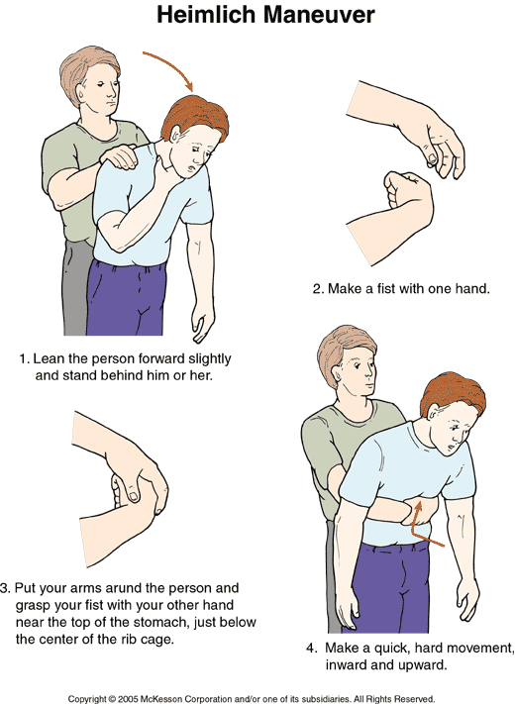

Pulmonary resuscitation
There are two methods of performing artificial breathing: mouth-to-mouth and mouth-to-nose. Regardless of the type of method used, remember to lean the head backwards, in order to clear the airways. If there is a suspicion of cervical vertebrae damage (head or neck trauma, fall from height, traffic accident), don’t lean the head back!
- mouth-to-mouth resuscitation
Head leaned back. Place one head on the patient’s forehead, the thumb and index finger occlude the nostrils. The rescuee’s lips are slightly parted. The rescuer presses his/her lips to the rescuee’s and exhales (not too deep, but deeper than normal).
Afterwards they quickly pull their head back and observes the rescuee’s chest. The effectiveness of resuscitation can be assessed based on chest movements and the sound of air coming from the rescuee’s mouth. There is a possibility that the air may go to the stomach (through the esophagus), instead of the trachea. This can cause a swelling of the stomach, which in turn may cause vomiting (possibility of aspiration). The prevent that, exhale the air slowly, c.a. 1.5-2s per exhale. Do not press the stomach to remove the air, which may gotten inside, as you may be risking aspiration.

Cardiac resuscitation
After cardiac arrest has been established, place the patient flat on a hard surface. If you lift the legs, it will increase the chance of successful resuscitation. Expose the patient’s chest. The pressure point for direct cardiac massage is on the lower part of the breastbone – 3 fingers above the xiphoid process.
The technique for direct cardiac massage in adults:
1. Place one wrist on the pressure point in the lower part of the breastbone, within the body axis.
2. Place the second wrist on the first. The fingers of both hands are lifted or interlocked, to prevent the ribs from breaking under pressure.
3. Pressure stage – Arms straight, shoulders vertically above the breastbone, compressions about 3-5cm deep. The rescuer should transfer body weight to straight arms to provide sufficient pressure.
4. Release stage – release pressure from the breastbone without removing the wrists from the pressure point; the chest should return to initial position.

Cardiopulmonary resuscitation
Since 2006 new standards for cardiopulmonary resuscitation are in force. There no longer is a division between one and two rescuer method. In each situation the cardiac massage and artificial breathing ratio is 30:2, i.e. two exhales per 30 compressions of the breastbone. Check the breathing and heart rate after each 4 cycles. the resuscitation should be continued until a doctor arrives. Earlier cessation is only allowed, if the rescuer is too exhausted to continue. You must be aware that the described action will most likely not restore basic life functions, as only intervention by an MD, who can administer appropriate medication and decide on defibrillation, can accomplish that. However even the best specialist using the best equipment will be helpless, if faced with a patient who went into cardiac arrest a few minutes prior and no one commenced resuscitation without equipment. That is why time and immediate commencement of rescue activities is of the essence.

