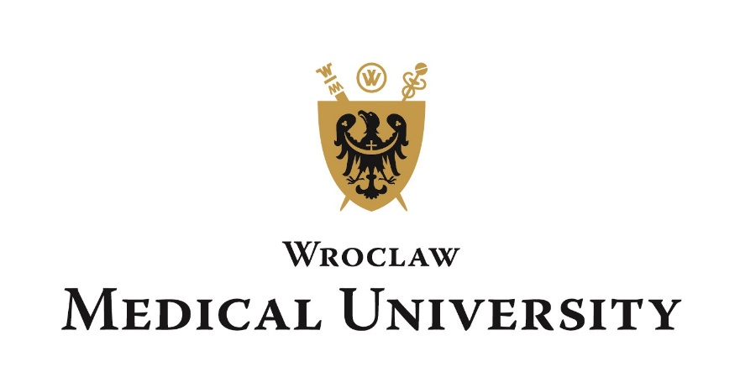

HEALTH CERTIFICATE
(Filled and signed by a physican)
Candidate for the English Programme, Faculty of Medicine/Dentistry

- Family Name …………………………. Given Name/Names …………………………………
- Gender: Male, Female* Title: Mr., Mrs., Ms., Miss*
- Date of birth: year …………….. month …………. day ………………………………….……
- Place and country of birth…………...…………………………………………………………..
- Contact address ………………………………………………………………………………….
- Proof of identity (document type, series, number) …………………………………………........

Candidate at

.………………………………………………………………………………………………………….
(field of study)

conducted in Wroclaw Medical University.

The above mentioned person will be exposed to the following factors that are harmful, disruptive or dangerous for health, including chemical agents – sensitizing irritant, formalin, infectious biological material, working on a display screen and optical microscope.

MEDICAL CONCLUSION
Applicant is in a good health and hence able to commence medical studies – YES/NO*
___________________________________
* circle the appropriate

